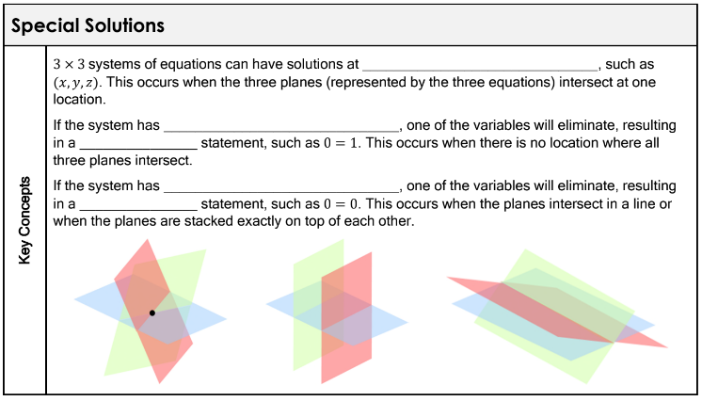
Example 1: Solve the system of linear equations by substitution
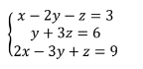

Example 2: Solve the system of linear equations by substitution
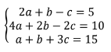

Try This! Summarize how to identify a system that has no solution or infinitely many solutions.

